Week-2
OLLAMA
Step-1: Install ollama from website
Step – 2: setup ollama
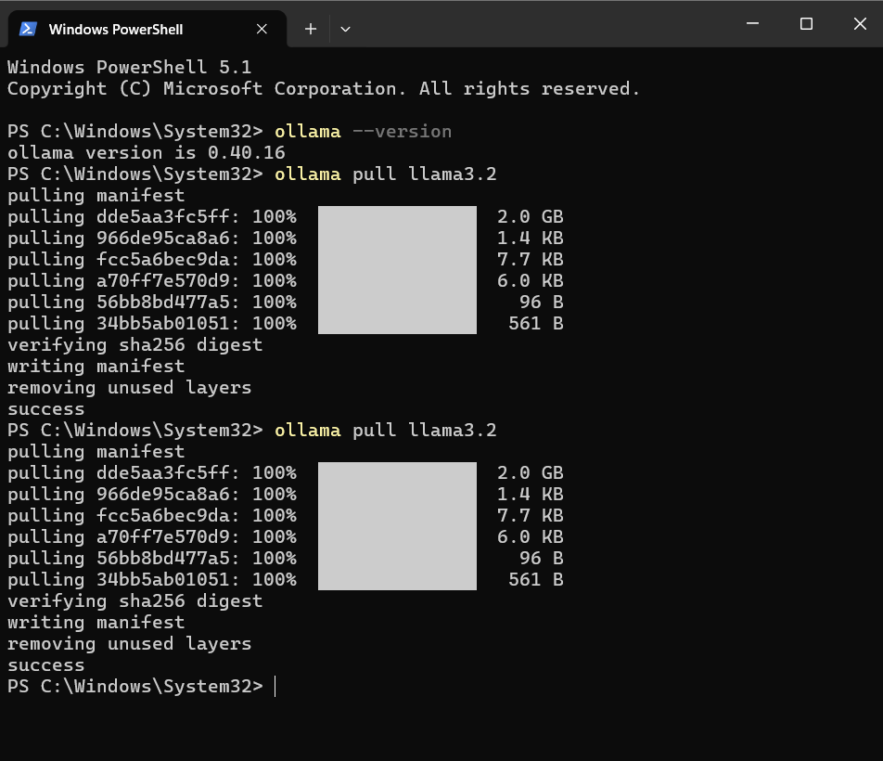
Step – 3:verify the ollama
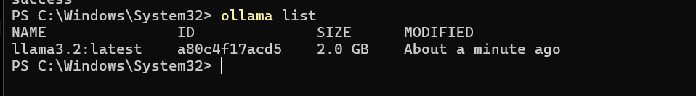

Step – 4: VS code set up
Create a folder with name week-2 and open it in vscode . Then create 5 files
With name .env,llm-client.py,main.py, requirements.txt, test_client.py
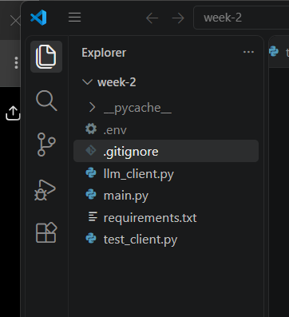

Step – 5: entre the code in the files

.env contains our gemini api key
.gitignore:
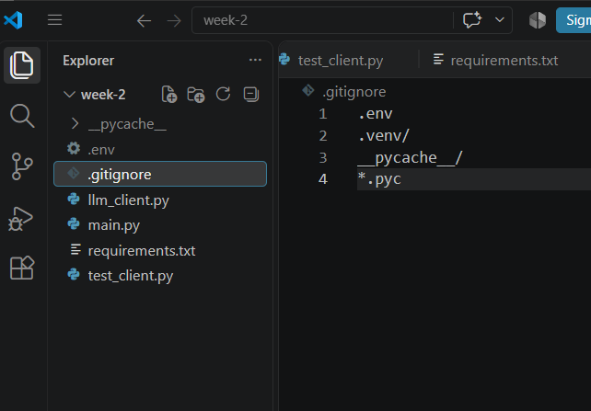

llm_client.py:
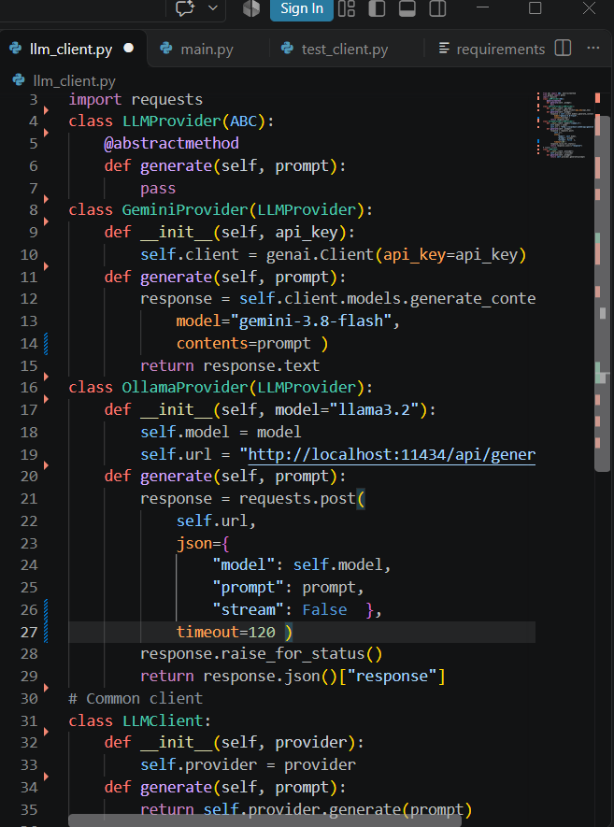

Main.py:
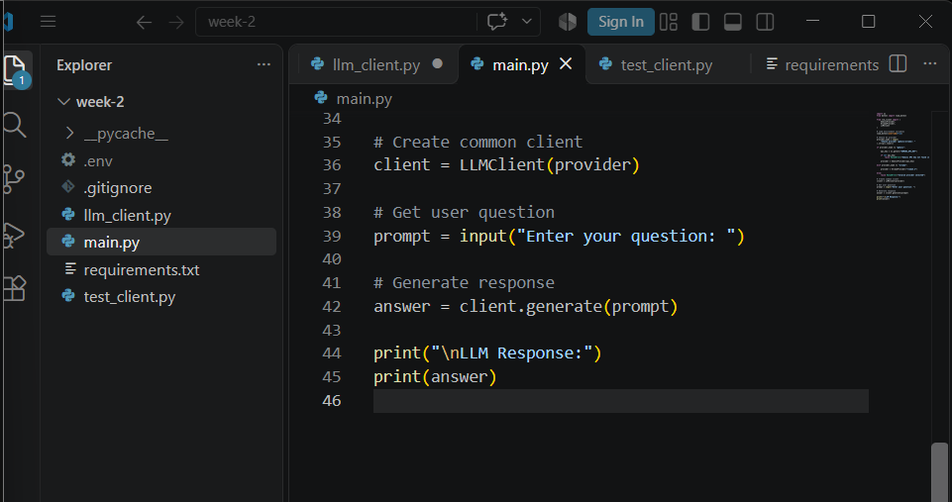
Requirements.txt:
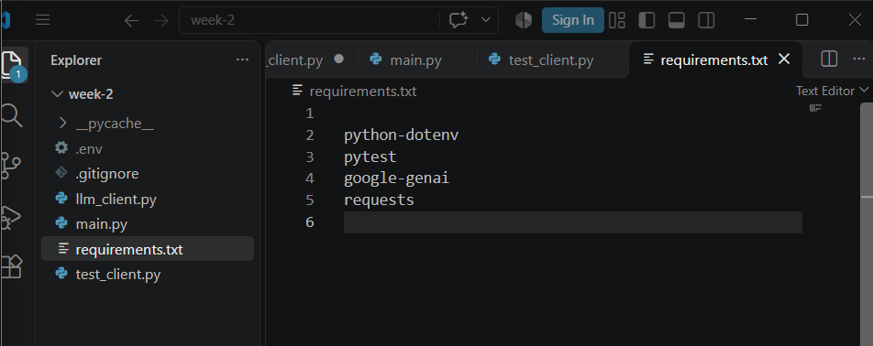
Test_client.py:
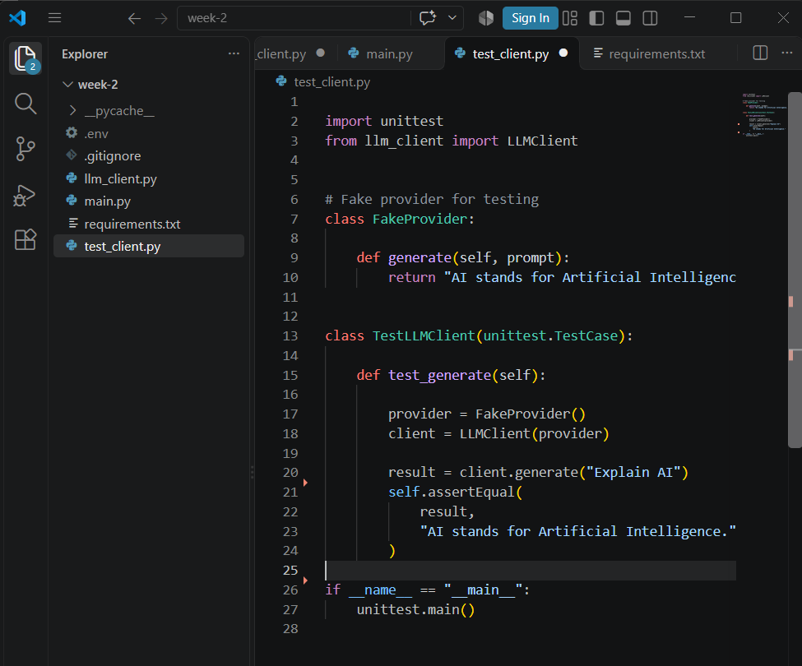

Step – 6: Download required libraries
1.python –version
2.pyhton -m pip –version
3.python -m pip install –upgrade pip
4.pyhton -m pip install -r requirements.txt
Step – 7:verify installation
Python -m pip list
Step – 8 : Run ollama model
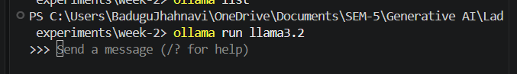

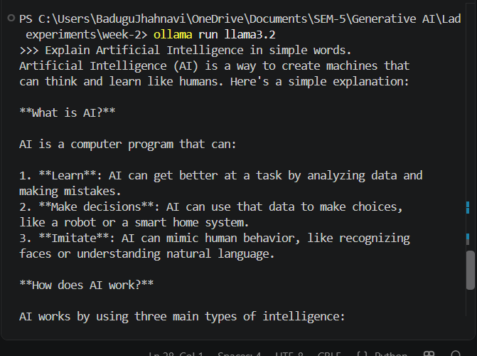

Step – 9: to interapt the action


